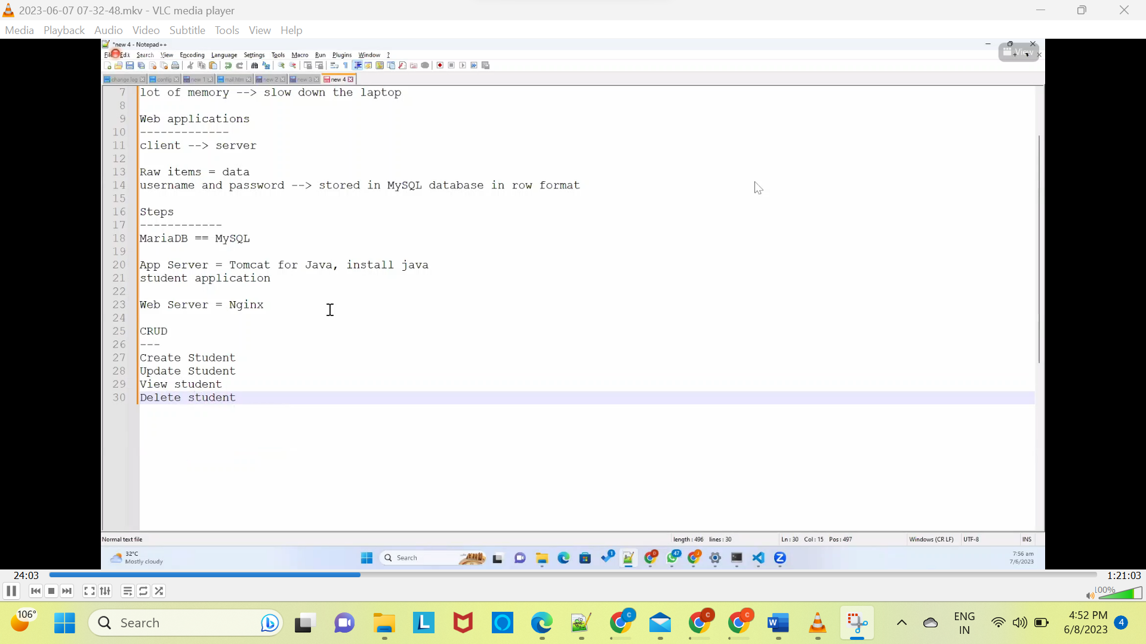

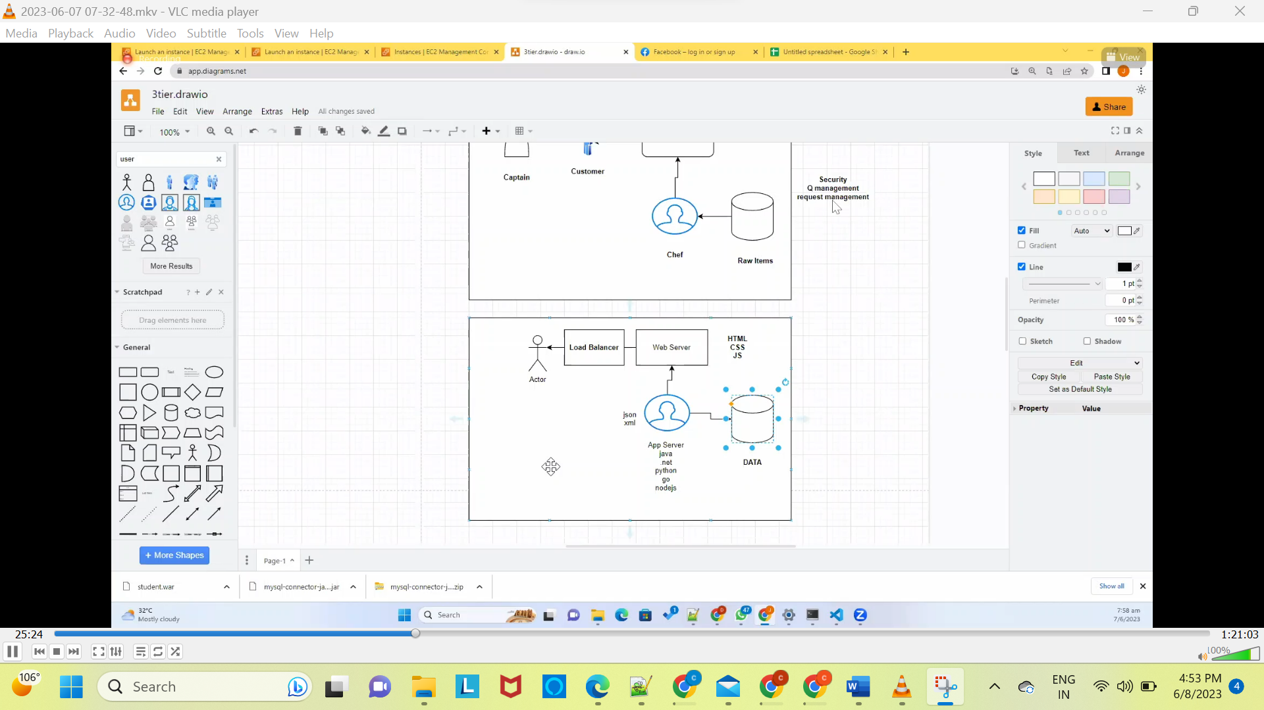

MariaDB:

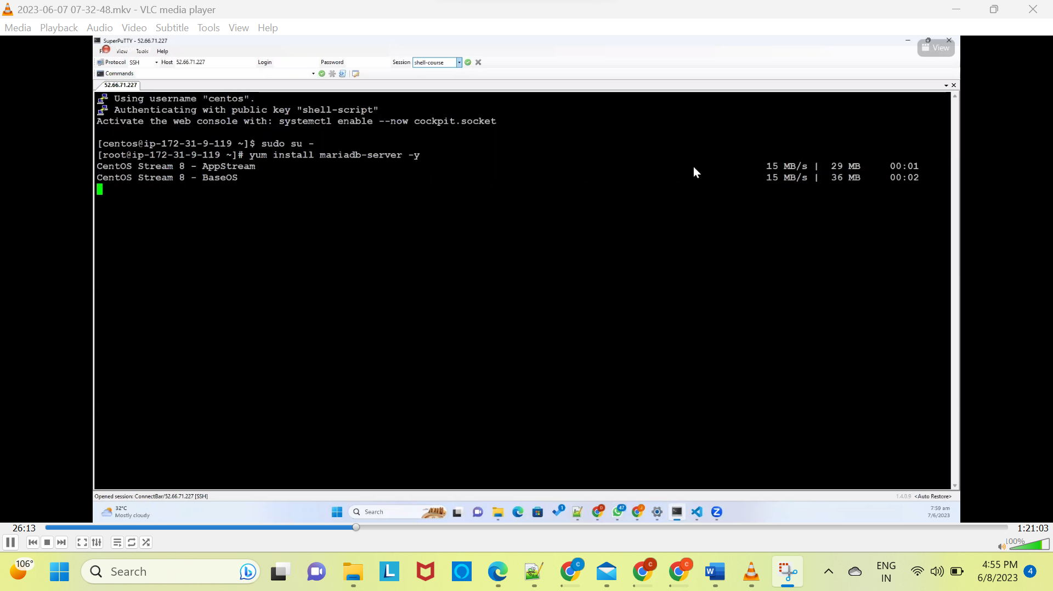

Sudo su –

Yum install maria-db -y

Once installed need to check mariadb started or not

Systemctl start mariadb

Systemctl status mariadb

Systemctl enable mariadb

Google(mariadb serverclient in centos8)

Yum install mysql -y

When you install mariadb server🡺mysql automatically installed



TOMCAT:

Tomcat download

Yum install wget -y





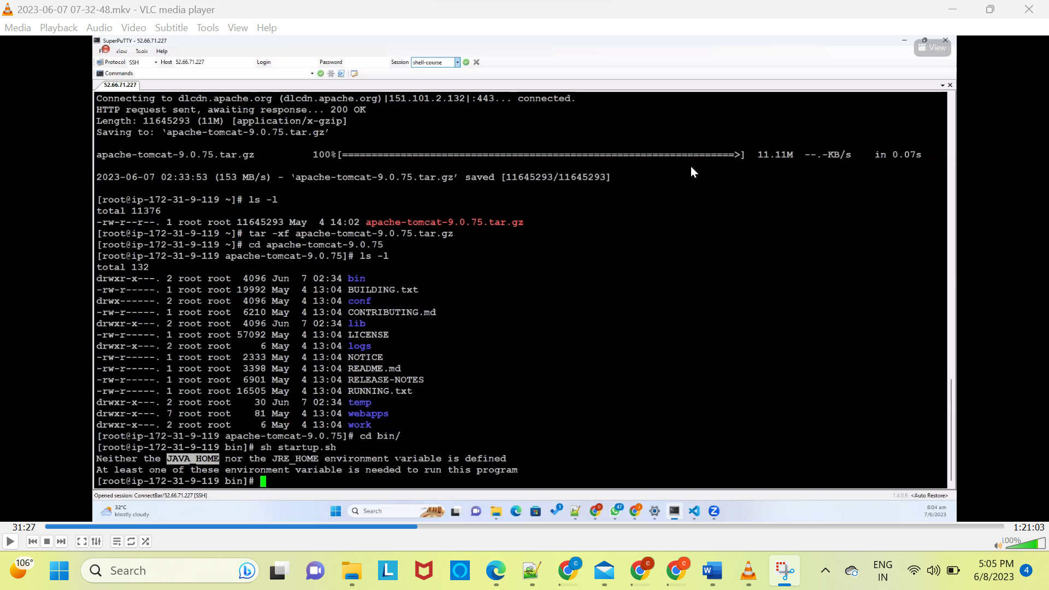

Insall java8 using centos



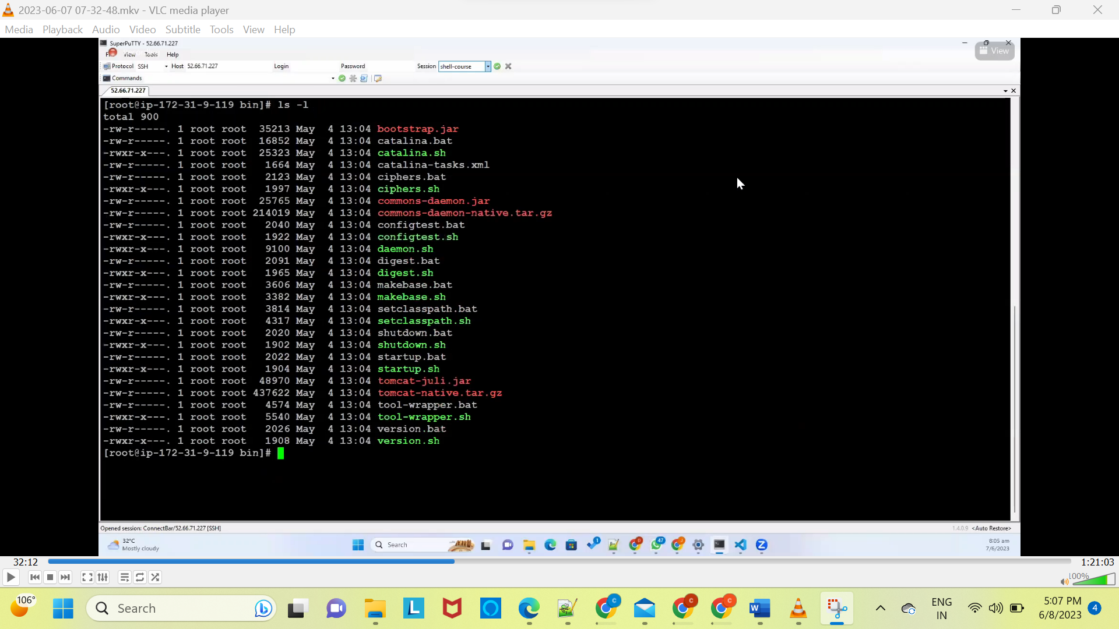

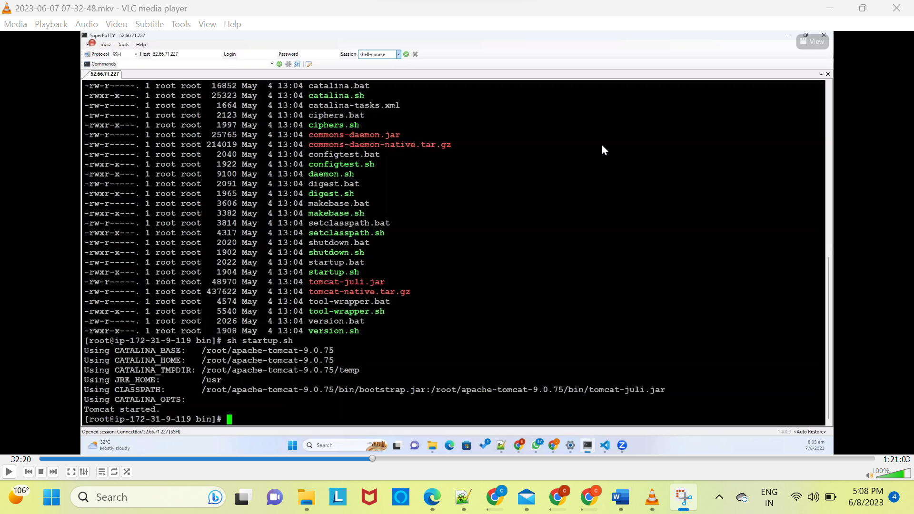

Yum install net-tools -y

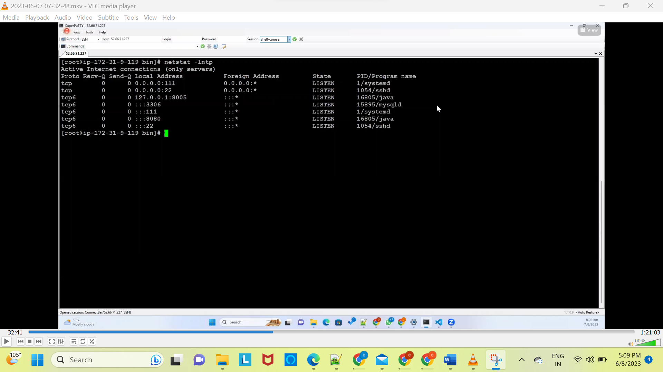



Tomcat installed successfully

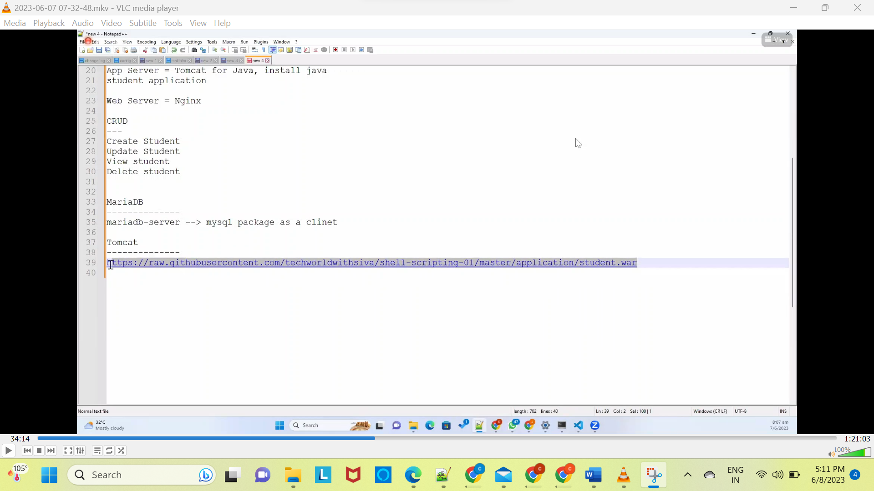

Now download war file from the github

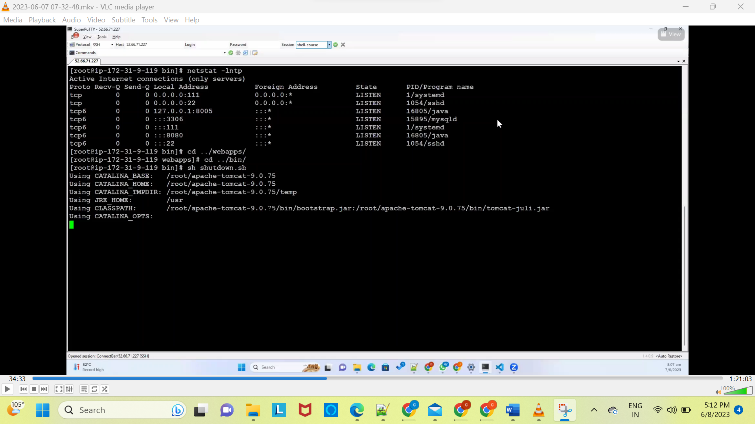

Cd ../webapps/

Cd ../bin/

Sh shutdown.sh



Under webapps we need to download war file

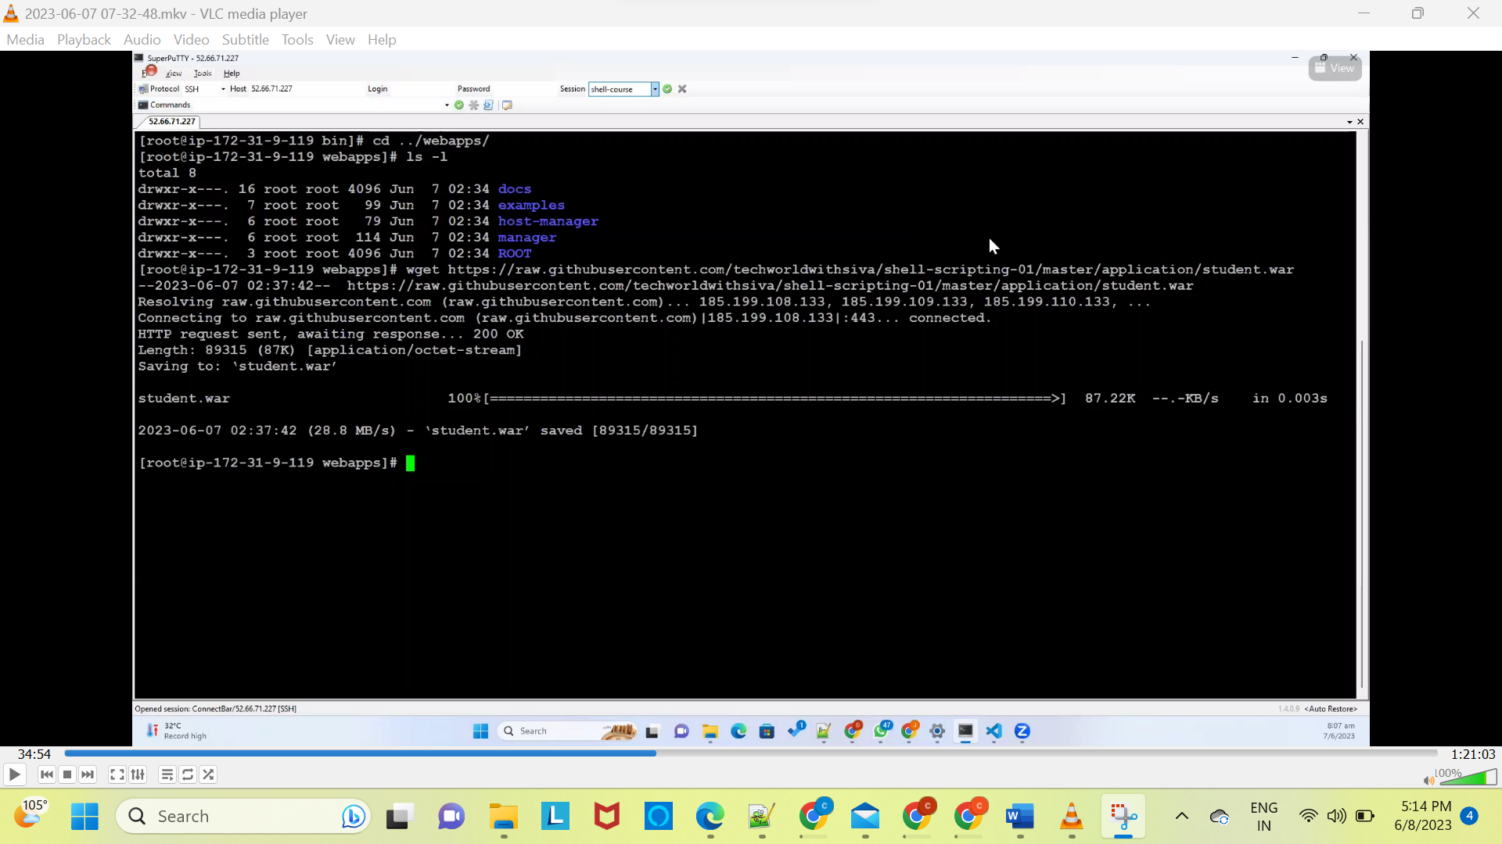

Ls -l

Take another window putty

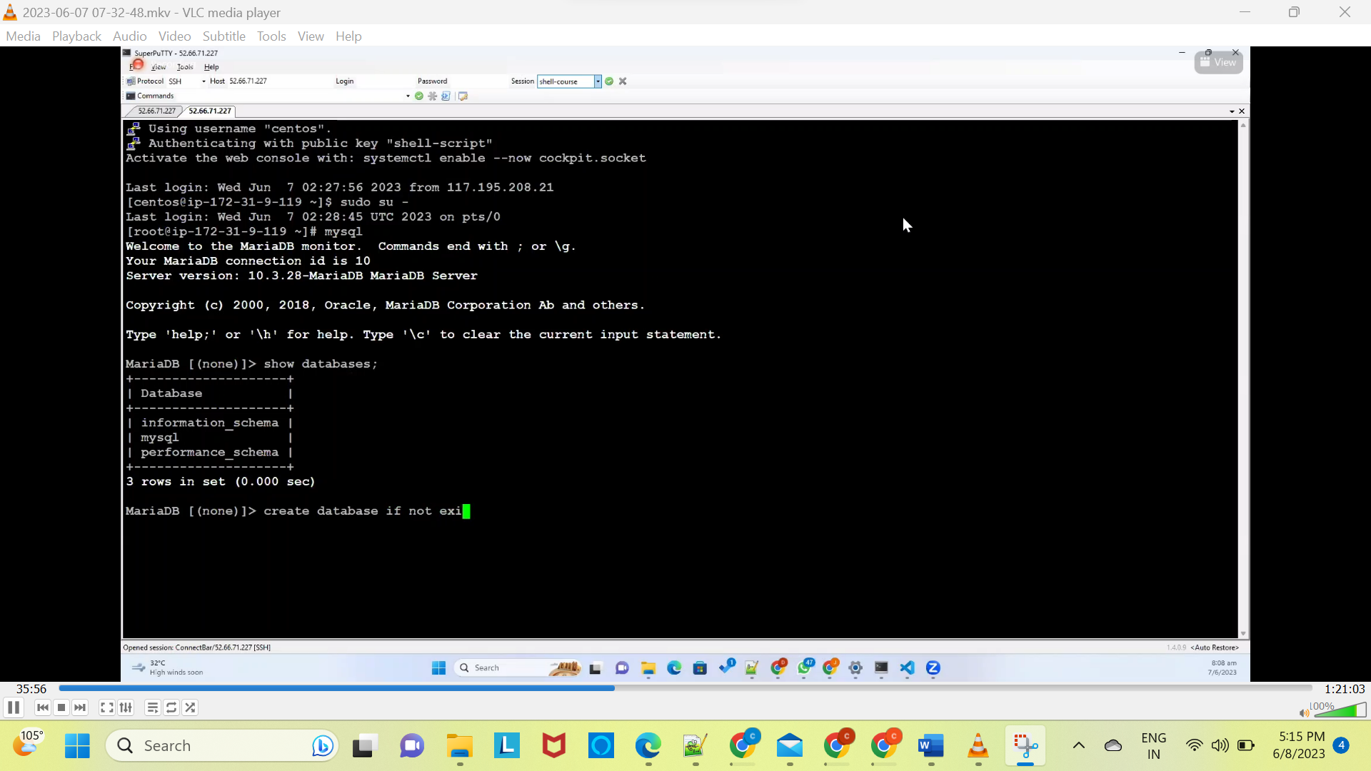

Create database if not exists studentapp

Use studentapp

Show tables

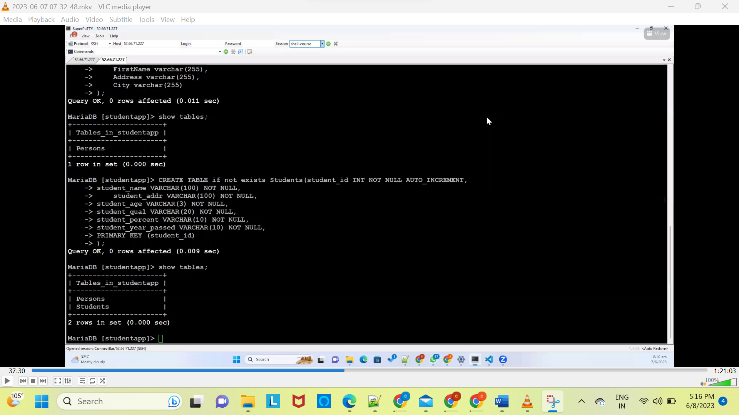

The above shows creation of studnettable



Connection between appliationserver and database

Application server --🡪 to -🡪 database



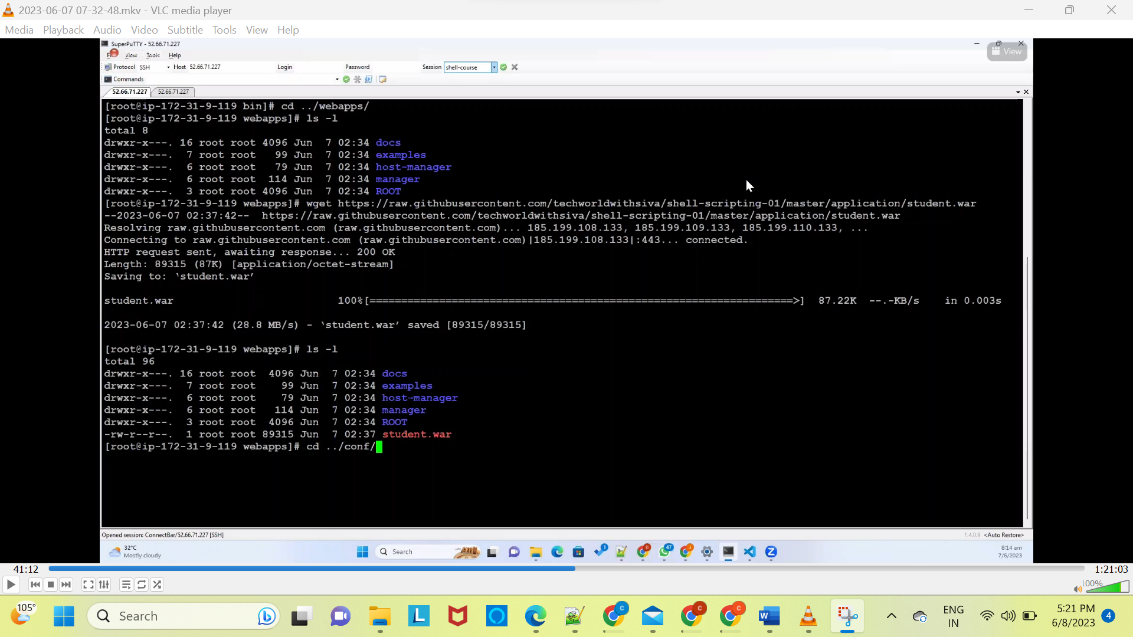

Under conf directory

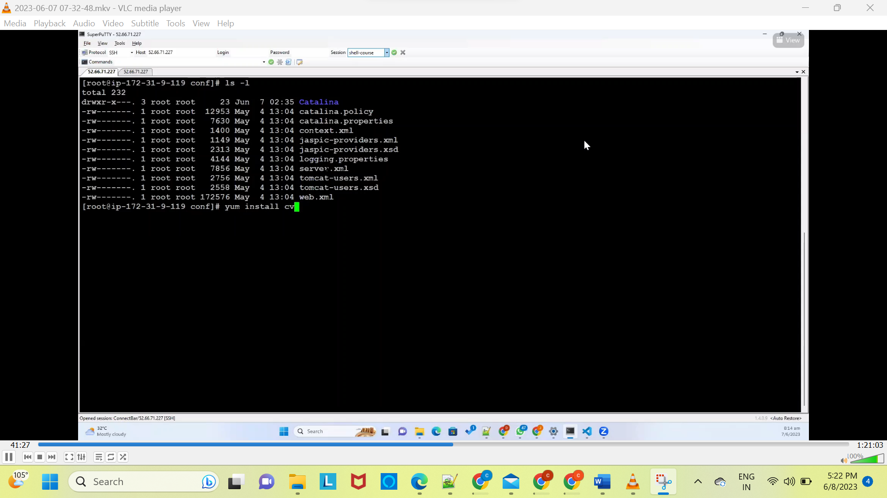

Yum insall vim -y



Under context.html we need to provide above code

Now we need download libararies also

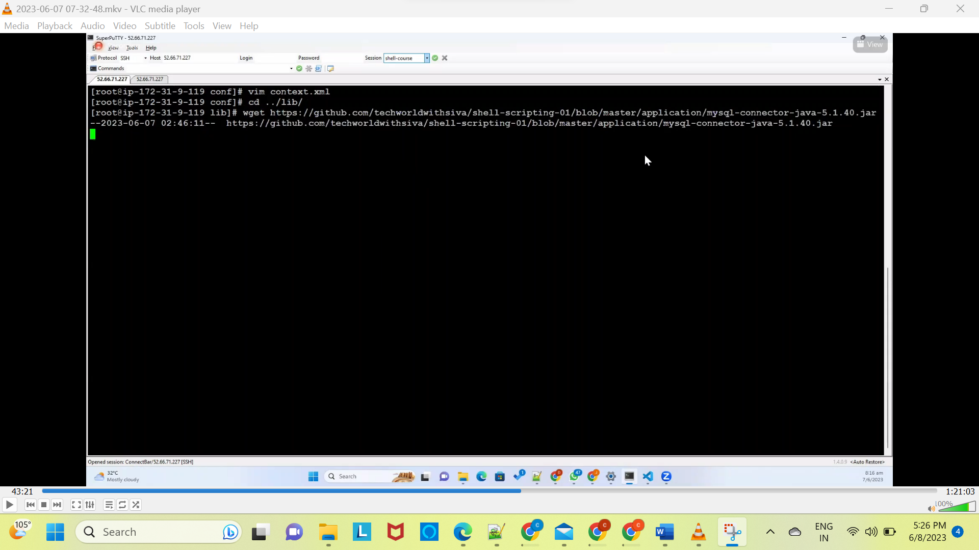

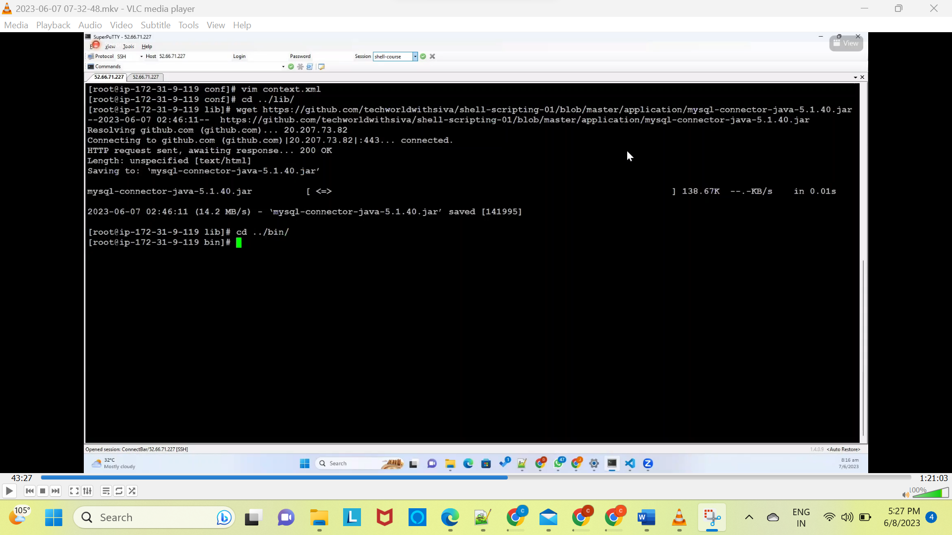

Sh startup.sh(it will start webapp)

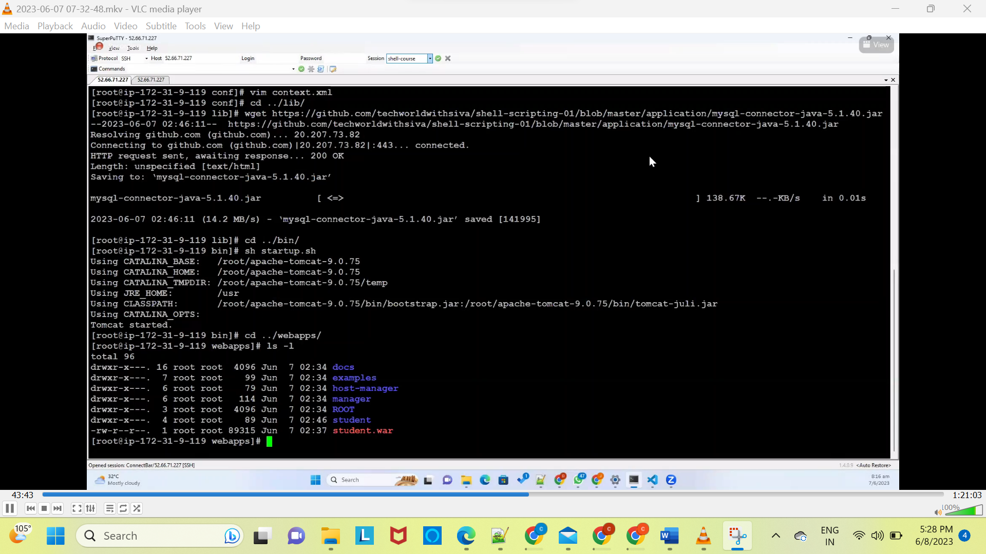

Cd logs

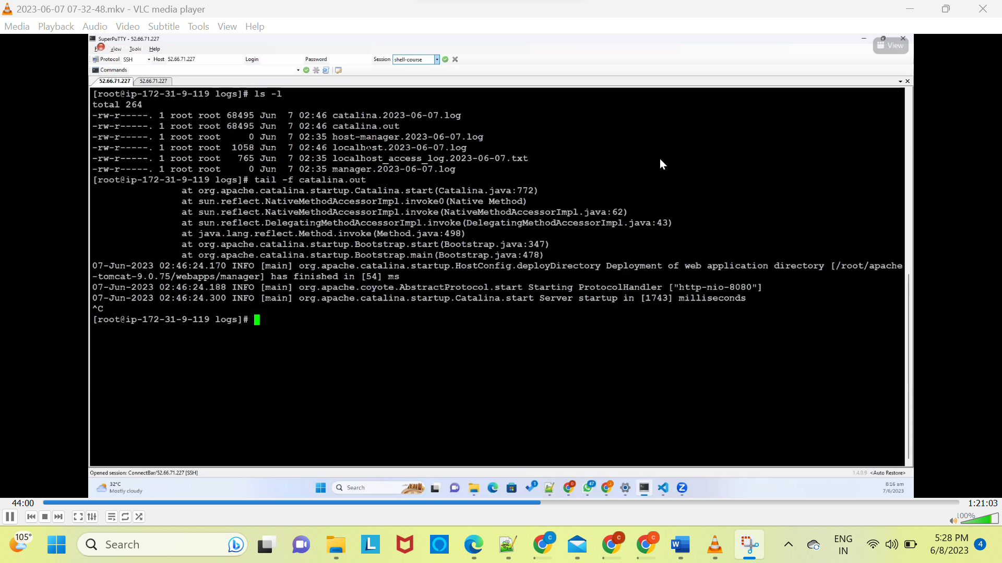



Less Catalina.2023-06-07.log

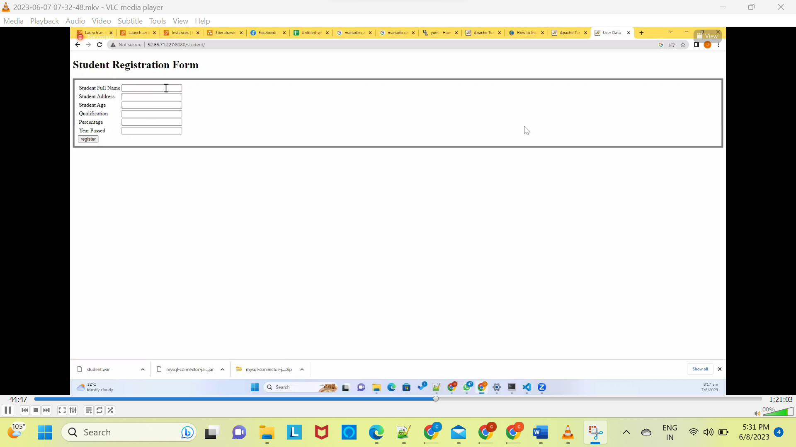

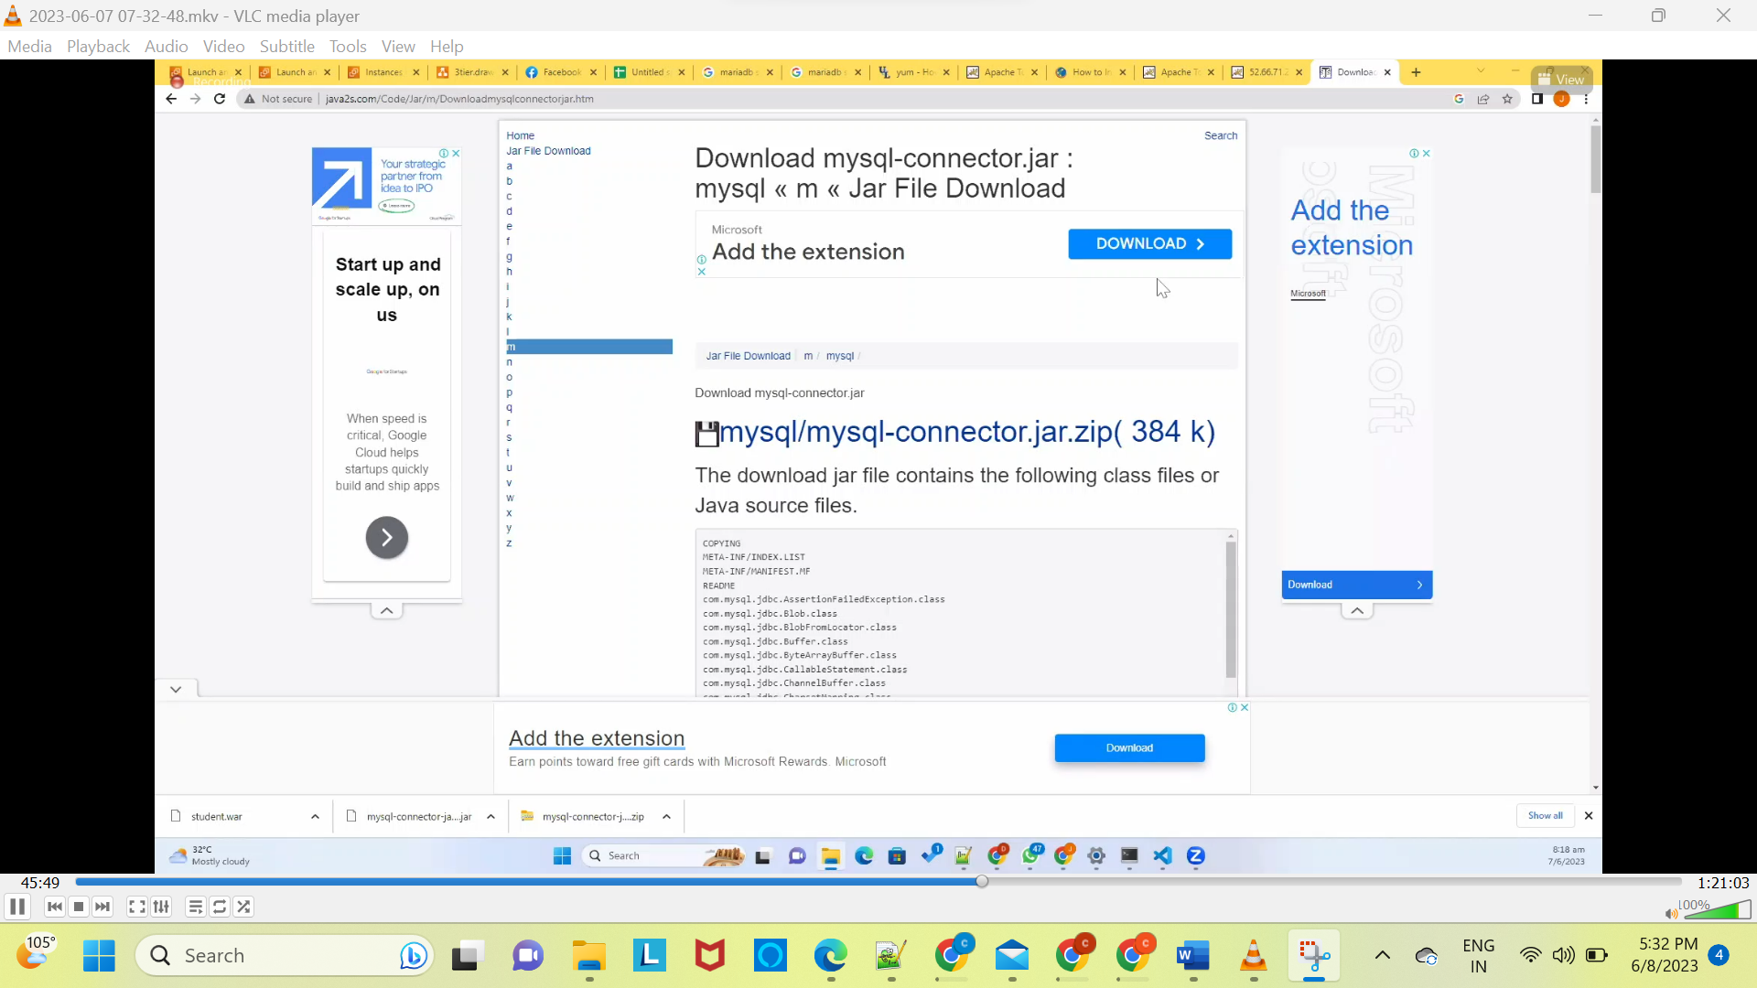

Now we need to fix jar issue

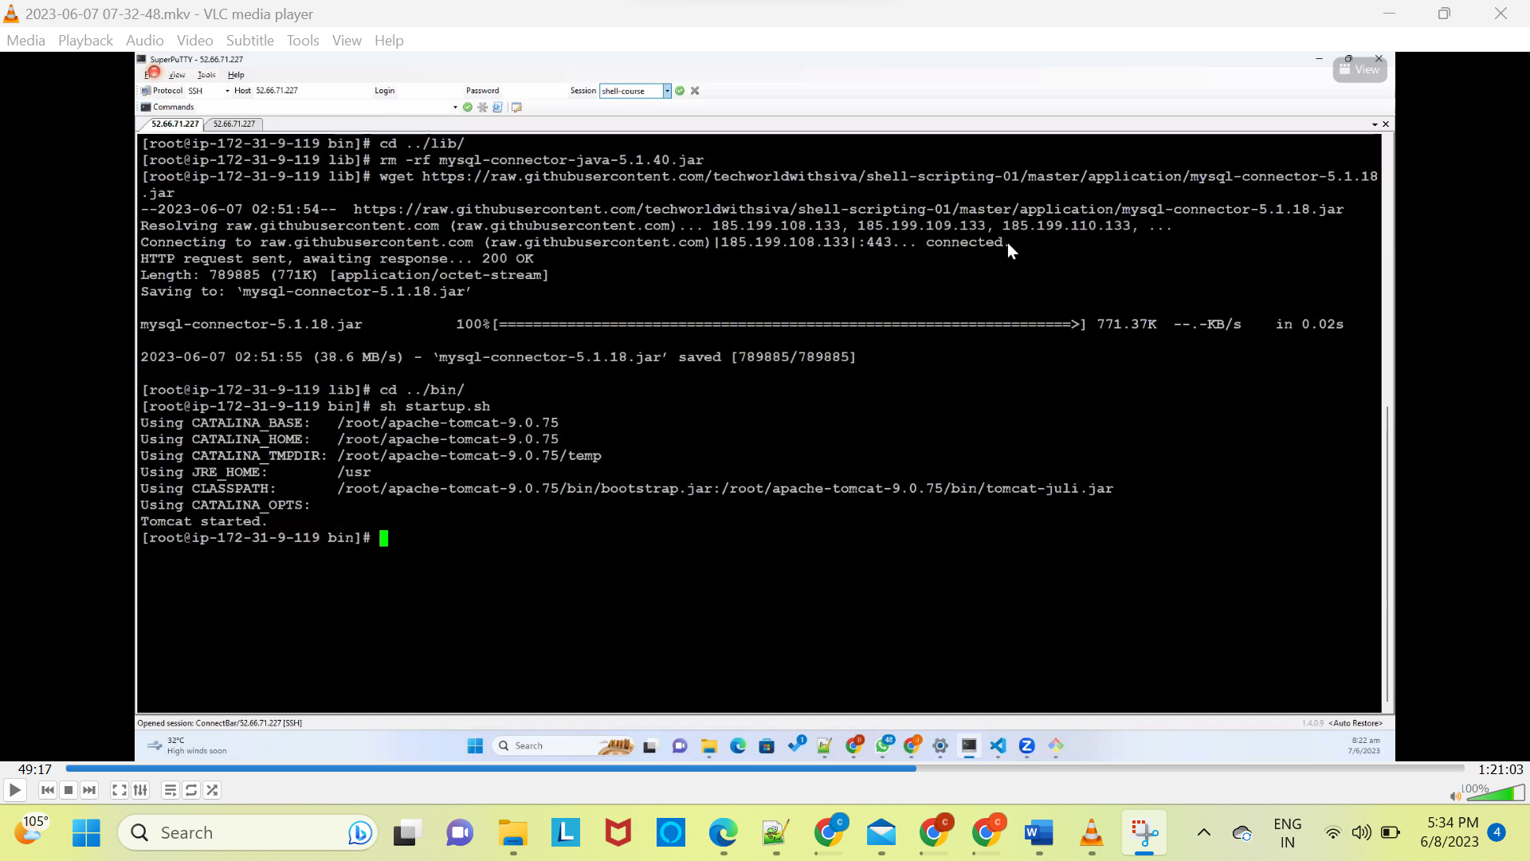

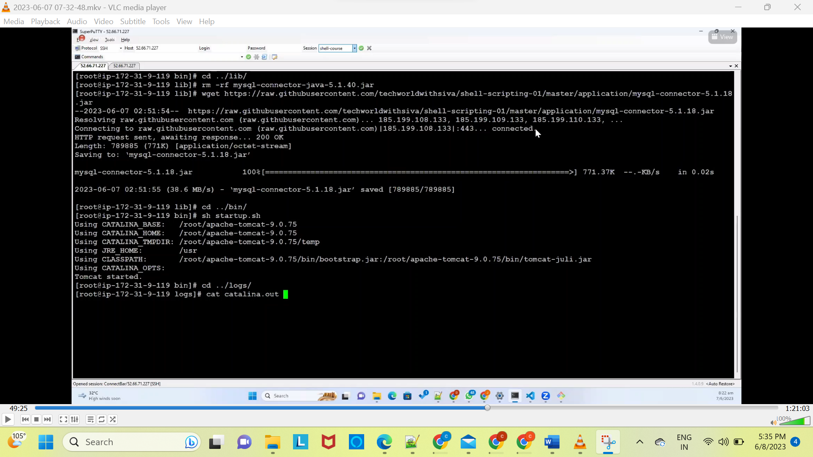

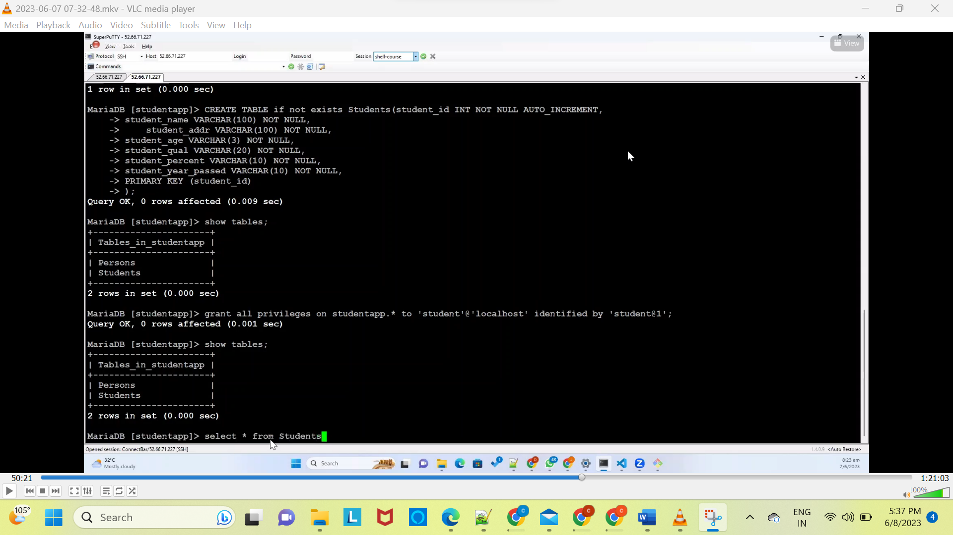

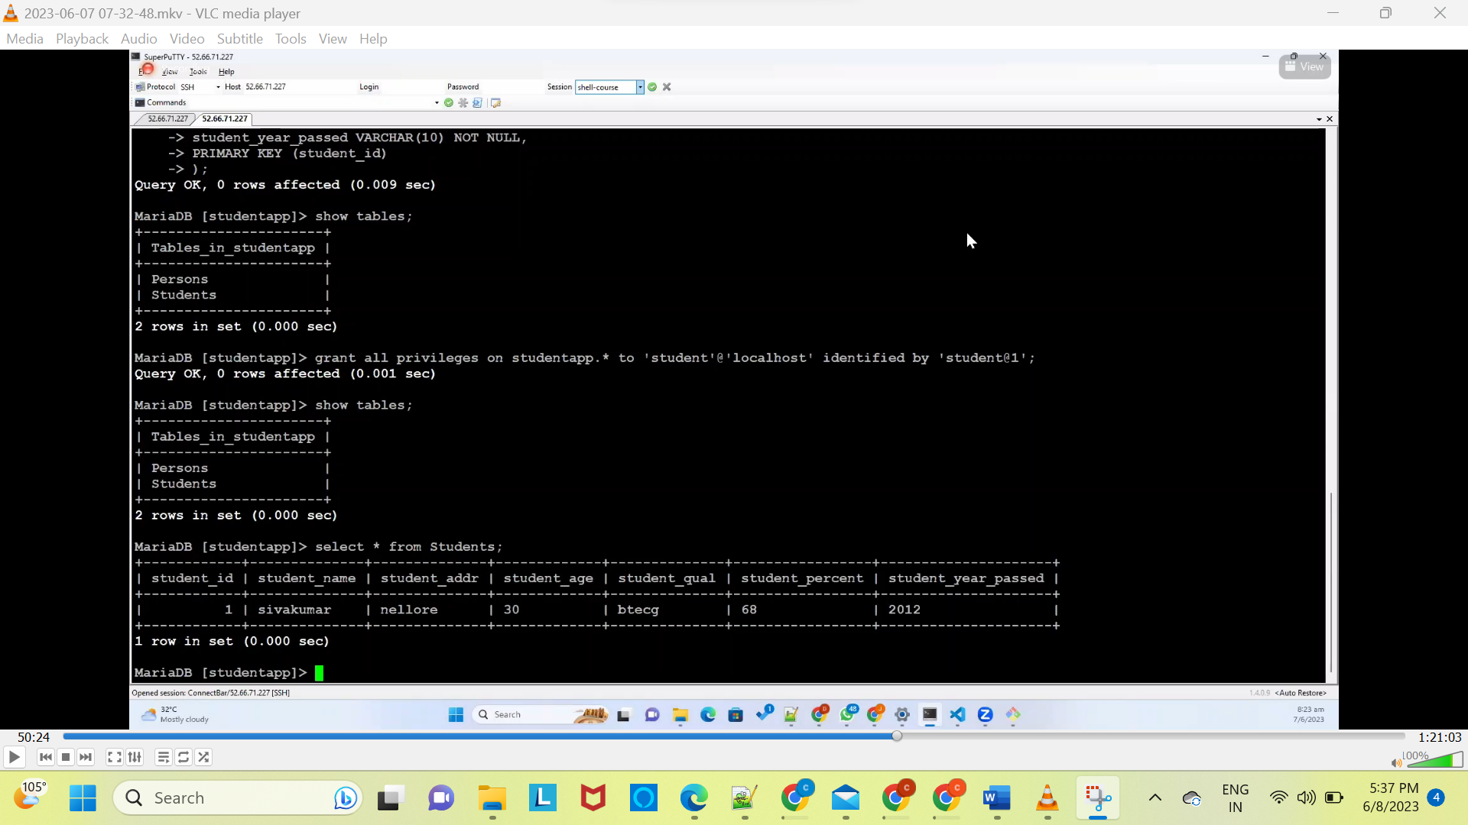now try to update it

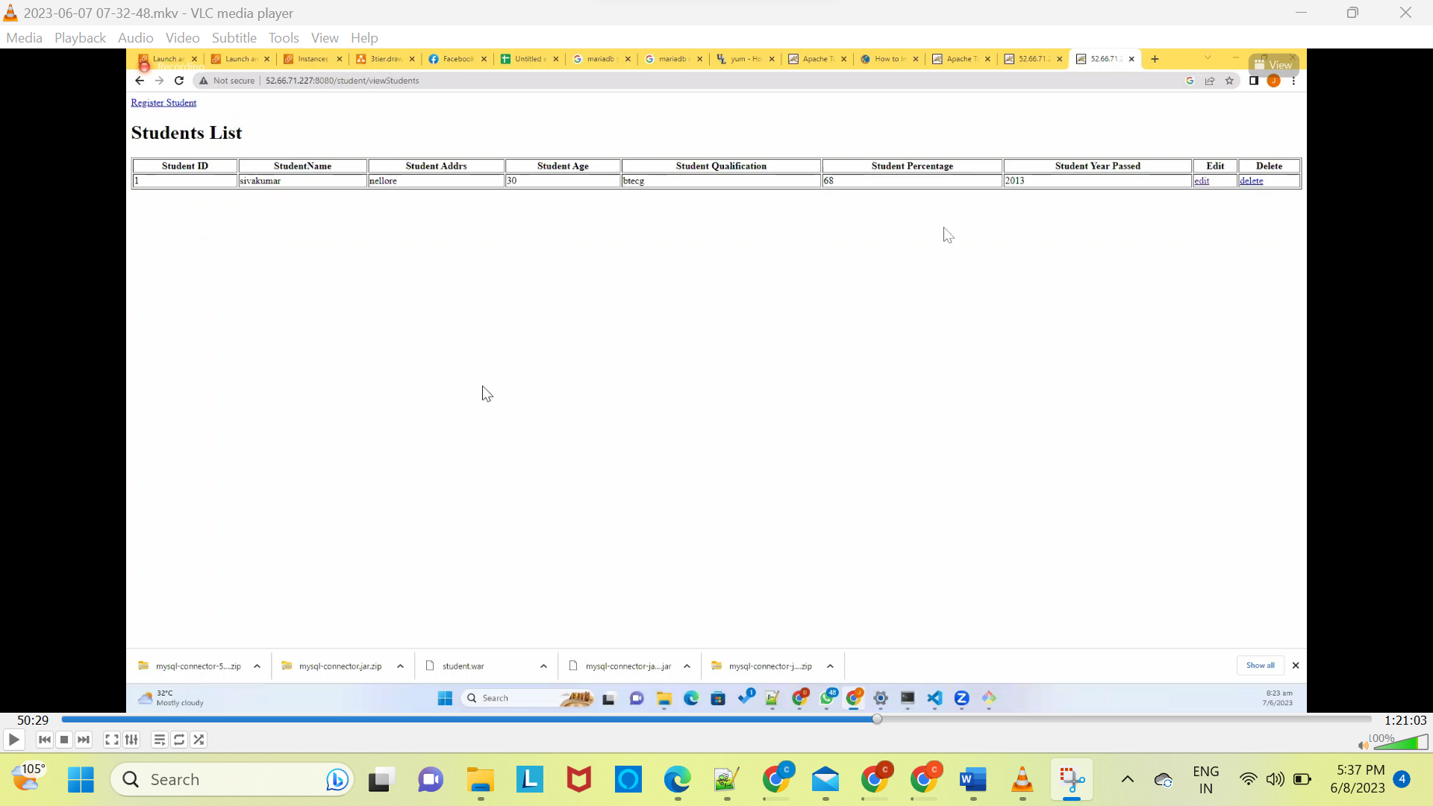



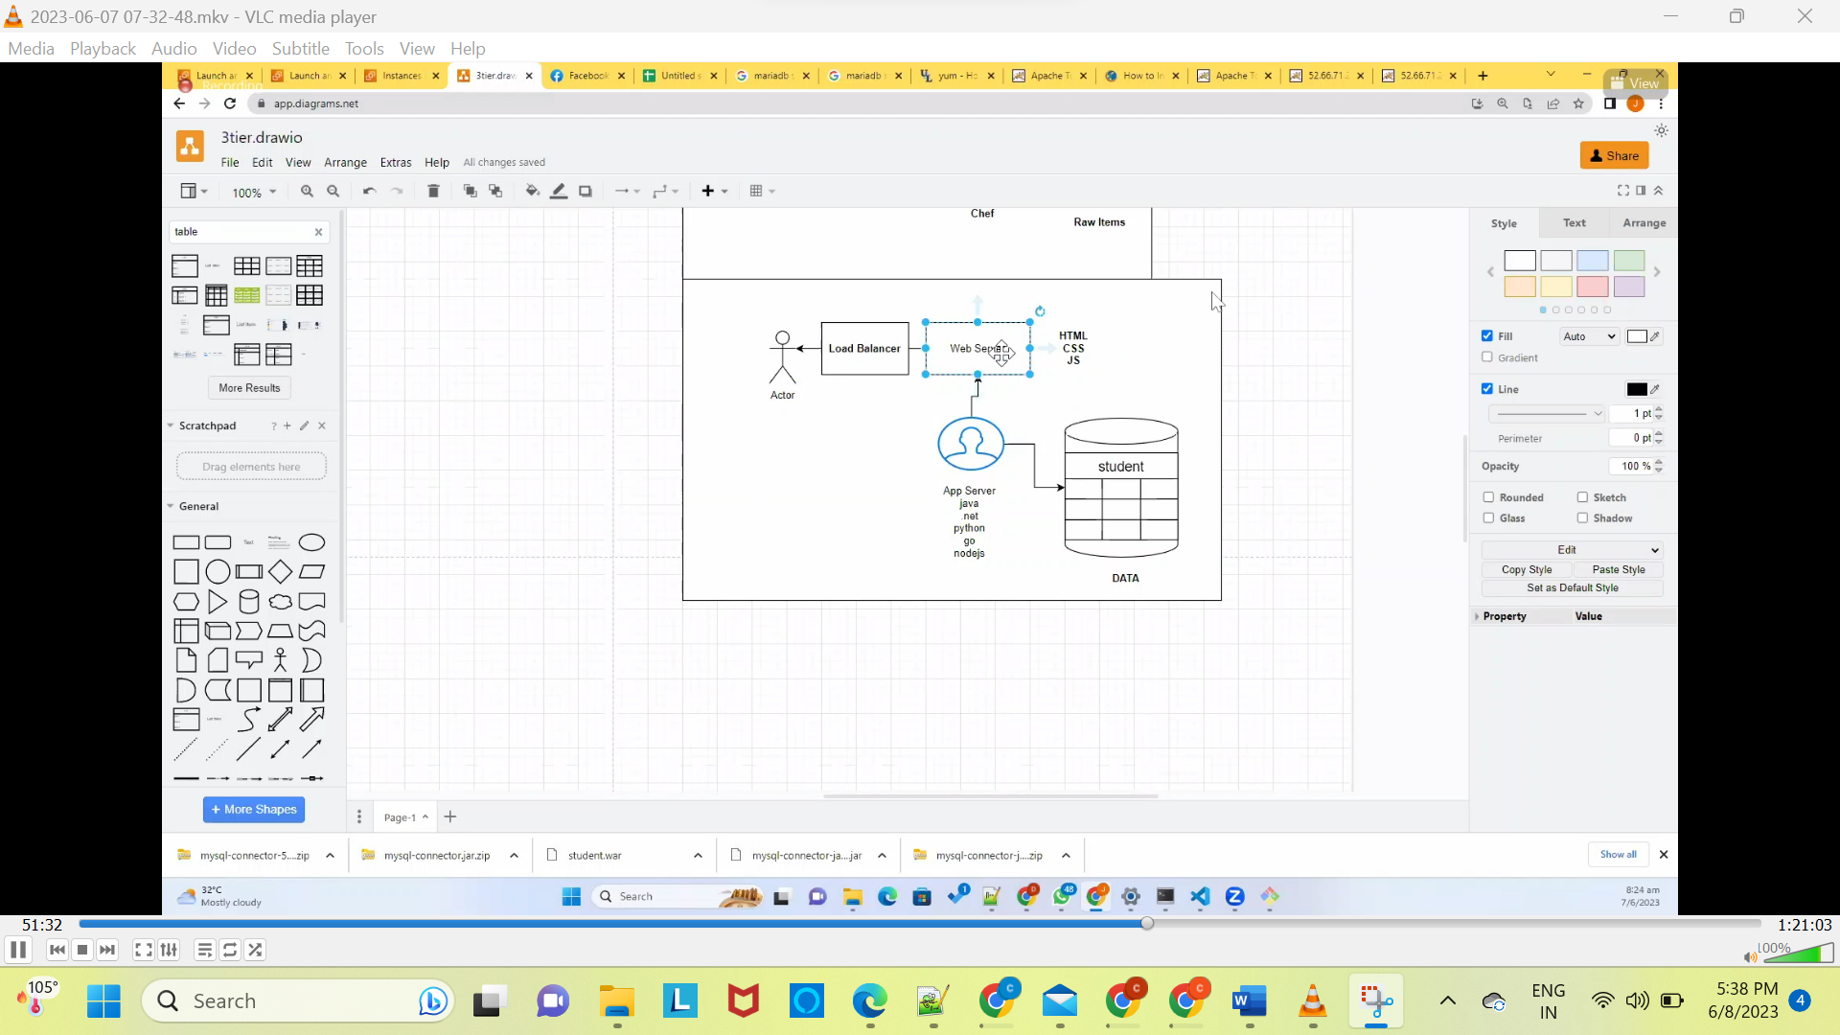

Doing the same things using shell script automation

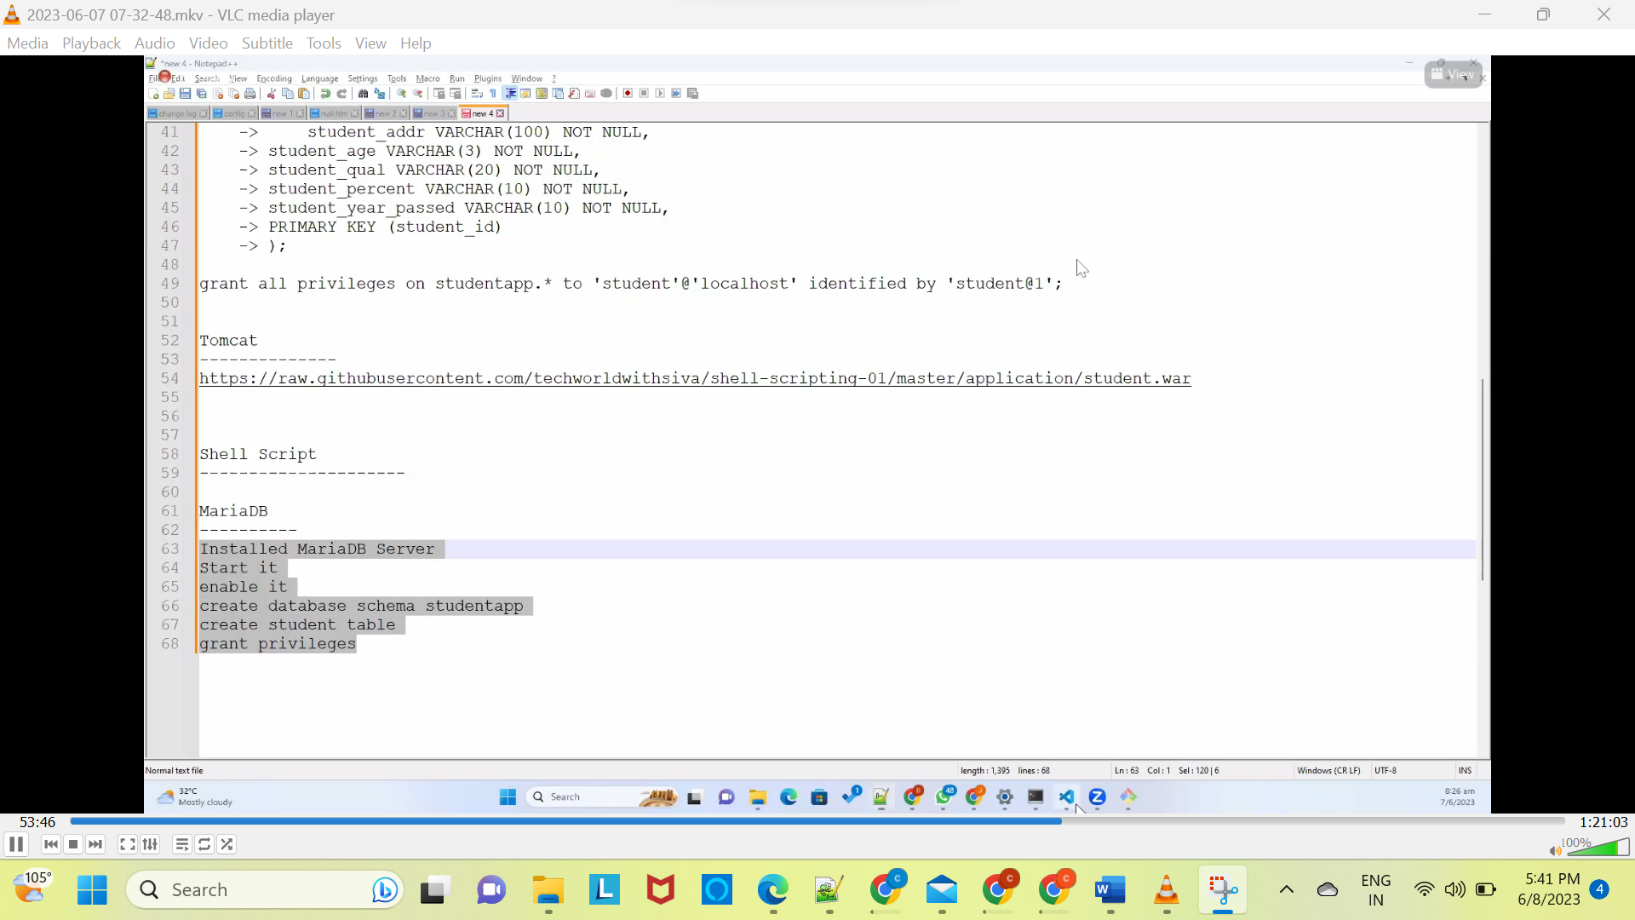

Create student.sh using winscp